- What is the difference between the chemical composition of soaps and detergents? State in brief the action of soaps in removing an oily spot from a shirt. Why are soaps not considered suitable for washing where water is hard?
Answer. oaps are sodium or potassium salts of fatty acids having — COONa group. Detergents are
sodium or potassium salts of sulphonic acids having — SO₃Na and — SO₄Na group. Cleansing action of soap: Soap molecules consist of a large hydrocarbon tail which is hydrophobic (water-hating or water repelling) with a negatively charged head which is hydrophilic (water-loving) as shown in figure.
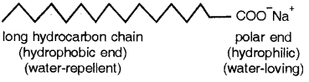
When a soap is dissolved in water, the molecules associate together as clusters called micelles in which water molecules, being polar in nature, surround the ions and the hydrocarbon part of the molecule attracts grease, oil and dirt.
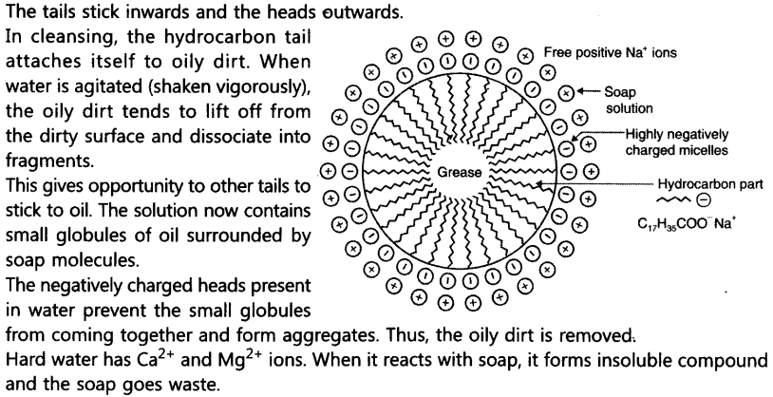
- List in tabular form three physical and two chemical properties on the basis of which ethanol and ethanoic acid can be differentiated
Answer.
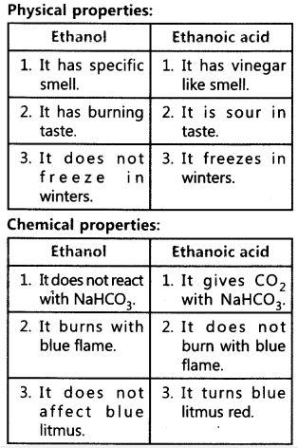
- What are the hydrocorbons write the name and general formula of (i) sturated hydrocarbons, (ii) unsaturated hydrocarbons, and draw the structure of one hydrocarbon of each type. How can an unsaturated hydrocarbon be made saturated?
Answer.
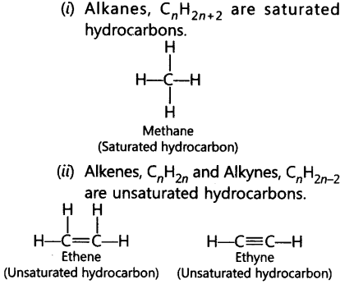
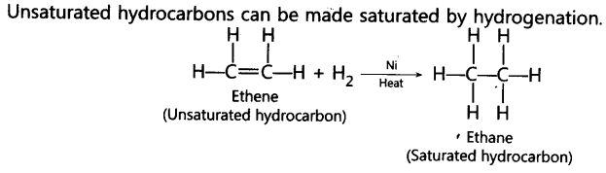
- What are detergents chemically? List two merits and two demerits of using detergents for cleansing. State the reason for the suitability of detergents for washing, even in the case of water having calcium and magnesium ions.
Answer. Detergents chemically are sodium or potassium salts of sulphonic acid of benzene or alkene.
Merits:
(i) They work well with hard water.
(ii) They are more effective than soaps.
Demerits:
(i) They are expensive.
(ii) Some of them having branching are non-biodegradable, therefore create water pollution.
Detergents are suitable for hard water having Mg²⁺ and Ca²⁺ ions because they do not form insoluble salts with Mg²⁺ and Ca²⁺ ions.

